MEMO

**FROM:** Edward Ma, W0057568, 701

**TO:** Bill Cunningham

**DATE:** 12-6-2016

**SUBJECT**: DBAS 1001 Assignment #9

* **Existing System Details:**
  + The Appointment Scheduling System Design documentation from Assg4 using the following files
    - Assg8.accdb
* **Statement of Requirements**:
  + to complete each of the tasks listed in the “Your Work section of this assignment;” on the assg9.docx
* **Analysis:**
  + ERD and Data Dictionary Details on assg4.docx
  + 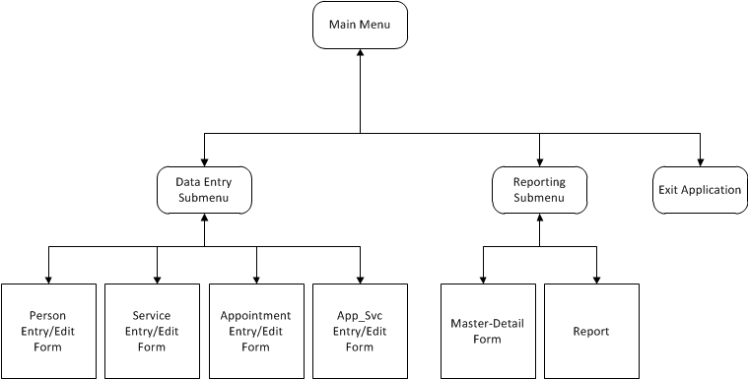 Functional Hierarchy Diagram
  + Storyboard is on assg8 answers.docx
* **Recommendation:**
  + Please accept the demonstration as evidence of the per-specification functionality of the data entry application.